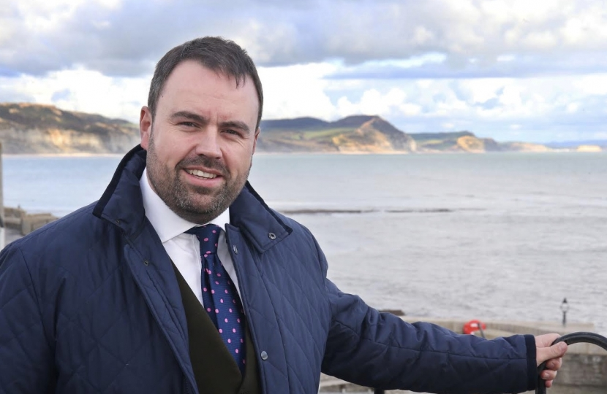
Chris Loader MP for West Dorset
Friday 7th June at Colin Nash Restaurant, The Retreat Lyndhurst Rd (A35), Hinton, BH23 7EF.
Chris was elected to Parliament in 2019. He is Parliamentary Private Secretary to the Secretary of State for the Environment, Food, and Rural Affairs
Born and Raised in West Dorset. He enjoyed a rural upbringing at Folke on the family farm as the 4th generation.
At 18 he began his railway career with a job as a train guard on the Waterloo to Exeter line, then as a manager for the Bournemouth to Weymouth line. In 2003, he moved from Sherborne to work with major rail operators in London, across the UK and then to Europe in 2010. Returning to the UK railways in 2012, he became Head of Service Strategy for a railway in the South West. He progressed to lead a team of 300 running the UK's best performing train company, creating more train services and better connections for Dorset, whilst delivering the multi-million-pound upgrade of London Waterloo station - the largest in Europe.
Long before being elected as MP, Chris developed his public service career when, at age 18, he became Parish Clerk for Bishops Caundle in 1998/99. For this, he was awarded the young person’s merit award for commitment to the local community. He was elected to West Dorset District Council to represent villages to the south of Sherborne in 2013 and was Association Chairman of West Dorset Conservative Association for three and a half years until August 2019.
In his spare time, Chris enjoys travelling, bellringing, classical music, national politics and rural affairs, and has held various voluntary roles including Chairman of the Institution of Railway Operators, Councillor of Southwark Cathedral and Director/Trustee of the Chartered Institute of Logistics and Transport as well as being a Freeman of the City of London. As a Christian, he has also been a member of Sherborne Parochial Church Councils and is an occasional organist at Folke, Bishops Caundle and other local churches. He learned to bell-ring at St James’ Church Longburton.

